1.Grouping product Category

2.Quantity sold by product category

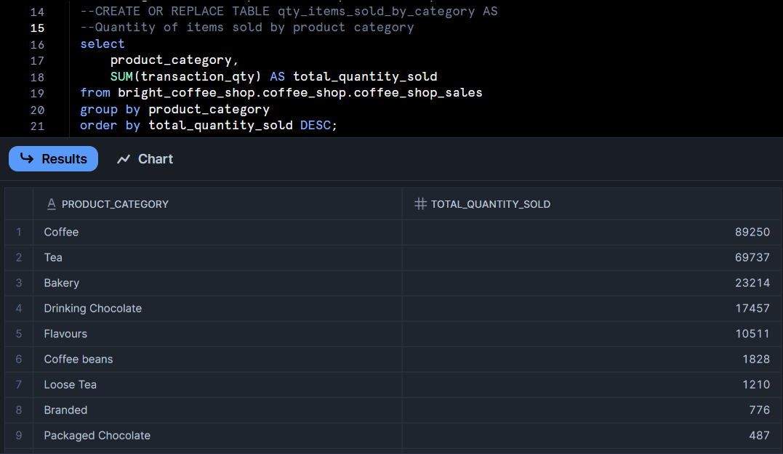

3. Total Revenue

4.Total sales per Location

5.Date and Time buckets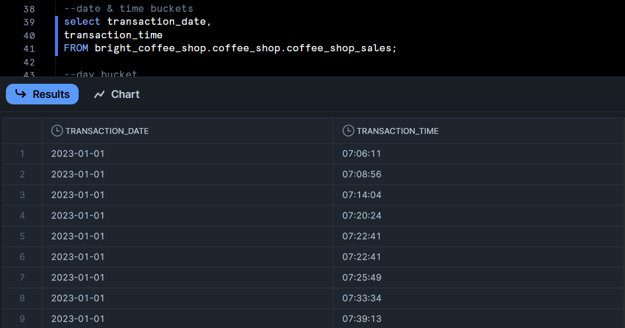

6. Creating day buckets

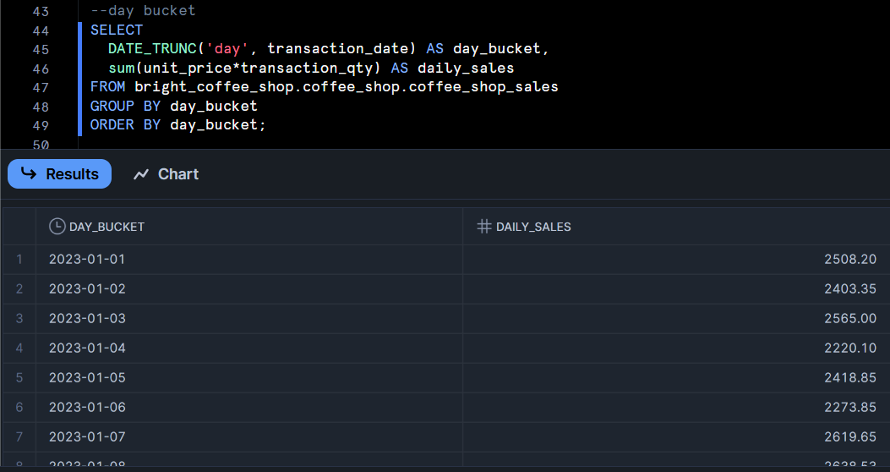

7. Weekly sales bucket

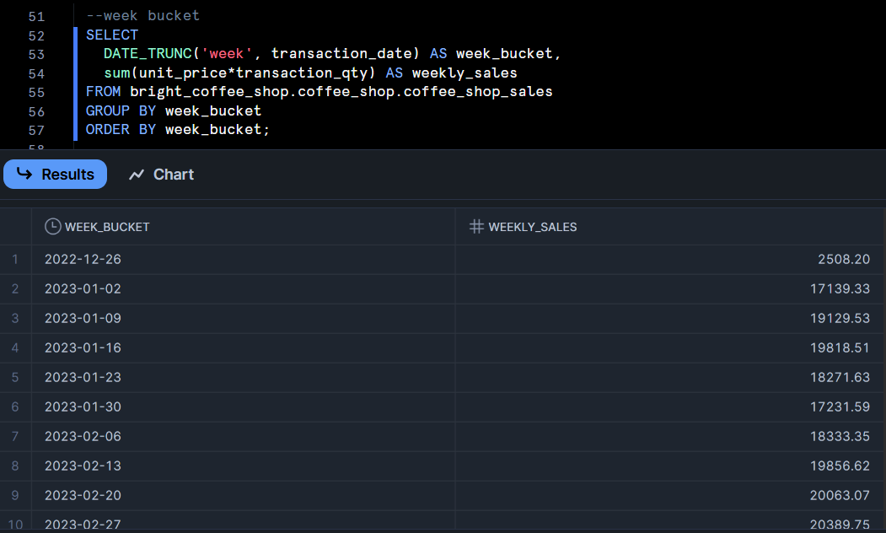

8.Monthly sales bucket

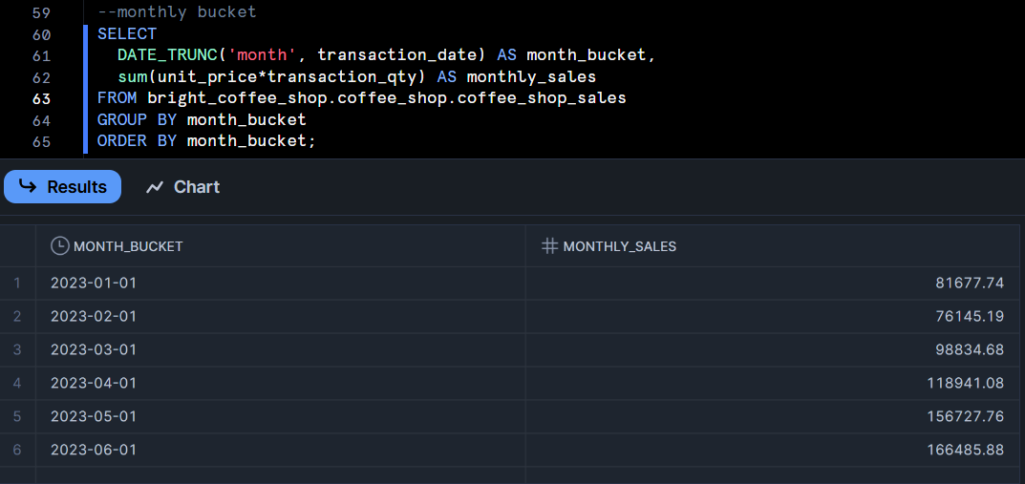

9.Extracting transaction time using CASE statement

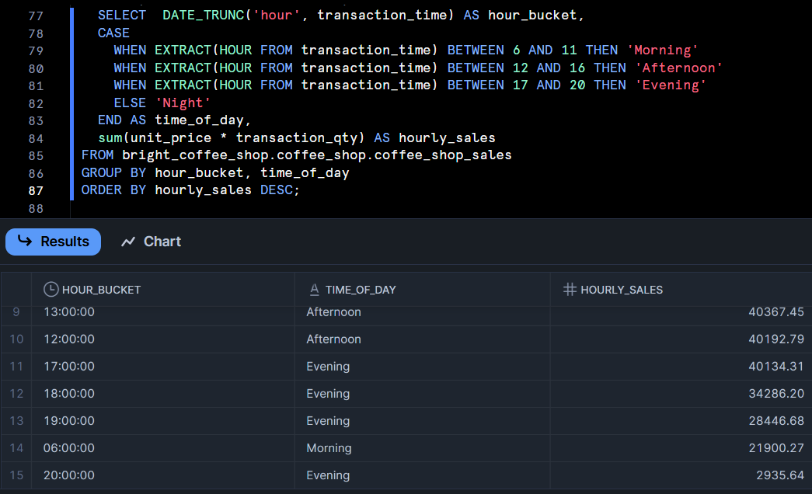

10.Most Selling products on peak hour

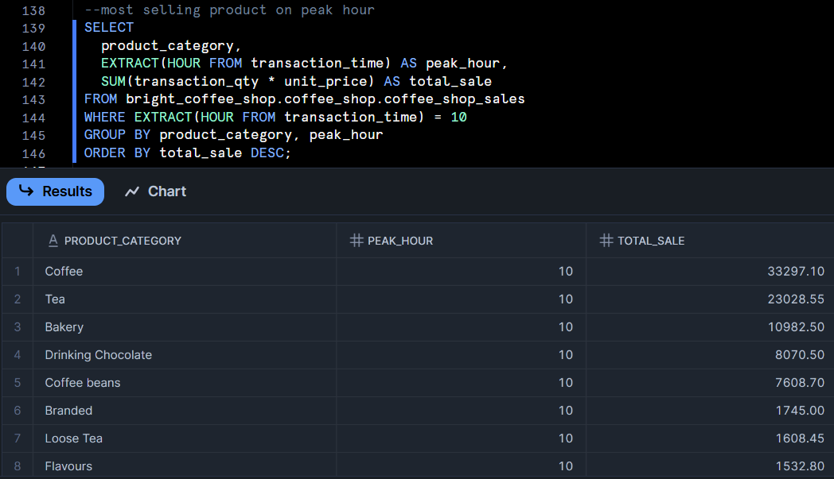

**Excel pivot tables.**

1.Sum of total revenue per category

2.Most selling product per category

3.Total Revenue per month

Dashboard using PowerBI.

